===== Kirana Bazar Application=====
## 1. High-level Overview (What we are building)
**Kirana Bazaar App (like Zepto/Blinkit)**
Core features:
* User app (browse, order)
* Admin app (manage products, orders)
* Delivery flow (basic)
* Single Spring Boot monolith
* REST APIs
* MySQL database
* CI/CD pipeline
* Deployed on cloud later (optional)

## 2. Tech Stack
**Backend**
* Java 17
* Spring Boot
* Spring Data JPA
* Spring Security (basic)
* Hibernate
* MySQL
* Maven

**DevOps**
* GitHub
* GitHub Actions (CI/CD)
* Docker
* Docker Compose
## 3. Monolithic Architecture (Simple & Clean)
Controller → Service → Repository → Database
## 4. Folder Structure (VERY IMPORTANT)
kirana-bazaar
│
├── src/main/java
│ └── com.kiranabazaar
│ ├── KiranaBazaarApplication.java
│ │
│ ├── config
│ │ ├── SecurityConfig.java
│ │ └── SwaggerConfig.java
│ │
│ ├── common
│ │ ├── exception
│ │ │ ├── GlobalExceptionHandler.java
│ │ │ └── ResourceNotFoundException.java
│ │ └── response
│ │ └── ApiResponse.java
│ │
│ ├── user
│ │ ├── controller
│ │ │ └── UserController.java
│ │ ├── service
│ │ │ └── UserService.java
│ │ ├── repository
│ │ │ └── UserRepository.java
│ │ └── entity
│ │ └── User.java
│ │
│ ├── product
│ │ ├── controller
│ │ │ └── ProductController.java
│ │ ├── service
│ │ │ └── ProductService.java
│ │ ├── repository
│ │ │ └── ProductRepository.java
│ │ └── entity
│ │ └── Product.java
│ │
│ ├── order
│ │ ├── controller
│ │ │ └── OrderController.java
│ │ ├── service
│ │ │ └── OrderService.java
│ │ ├── repository
│ │ │ └── OrderRepository.java
│ │ └── entity
│ │ └── Order.java
│ │
│ └── admin
│ ├── controller
│ └── service
│
├── src/main/resources
│ ├── application.yml
│ ├── data.sql
│ └── schema.sql
│
├── src/test/java
│ └── com.kiranabazaar
│ └── KiranaBazaarApplicationTests.java
│
├── Dockerfile
├── docker-compose.yml
├── pom.xml
└── README.md

## 5. Sprint Planning (End-to-End)

### 🟢 Sprint 1: Project Setup & Base Configuration
**Goal:** App runs locally
Tasks:
* Create Spring Boot project in Eclipse
* Setup MySQL connection
* Create base package structure
* Add Lombok, JPA, Validation
* Test health endpoint
Deliverables:
* App starts
* DB connected
* `/health` API works

### 🟢 Sprint 2: User Module
**Goal:** Users can register & login
Tasks:
* User entity
* UserRepository
* UserService
* UserController
* Basic authentication (no JWT yet)

APIs:
* Register user
* Login user
* Get user profile
### 🟢 Sprint 3: Product Module
**Goal:** Product browsing
Tasks:
* Product entity
* Admin add/update product
* User fetch products
* Pagination & sorting
APIs:
* Add product (admin)
* List products
* Search product
### 🟢 Sprint 4: Order Module
**Goal:** Place and track orders
Tasks:
* Order entity
* Order-item mapping
* Place order
* View order history
APIs:
* Place order
* Get orders by user
* Get order details

### 🟢 Sprint 5: Cart & Checkout
**Goal:** Shopping experience
Tasks:
* Cart logic (DB or in-memory)
* Add/remove items
* Checkout flow
* Calculate total price
### 🟢 Sprint 6: Admin Dashboard APIs
**Goal:** Manage business
Tasks:
* View all orders
* Update order status
* Manage inventory
* Low stock alerts

### 🟢 Sprint 7: Security & Validation
**Goal:** Production readiness
Tasks:
* Spring Security
* Role-based access (USER / ADMIN)
* Input validation
* Global exception handling

### 🟢 Sprint 8: DevOps (CI/CD)
**Goal:** Automated deployment
Tasks:
* Dockerize app
* Create Dockerfile
* Setup docker-compose (App + MySQL)
* GitHub Actions pipeline
Pipeline:
Code Push → Build → Test → Docker Image → Deploy

## 6. CI/CD (GitHub Actions – Simple)
Example flow:
```yaml
- Checkout code
- mvn clean install
- Build Docker image
- Push image
- Deploy

• Controller → Handles HTTP requests
• Service → Business logic
• Repository → Database interaction
• Entity → Database models
• Config → Configuration classes

Add Lombok, JPA, Validation

🔹 Lombok

What it does
Auto-generates:
- getters
- setters
- constructors
- toString

Why we use it
- Reduces boilerplate code
- Cleaner classes
- Faster development
Without Lombok :
100 lines → 20 lines (we have reduced from 100 lines of codes to 20 lines of codes while using Lombok)
From just 3 annotations ( @Data, @NoArgsConstructor & @AllArgsConstructor) Lombok creates:
- Getters
- Setters
- Constructor with fields
- No-args constructor
- toString()
- equals() and hashCode()
All at compile time. No runtime overhead.

Spring Data JPA

What it does
- Connects Java objects to database tables
- Handles CRUD automatically
- Eliminates manual SQL for common operations

Why we use it
- Faster development
- Less bugs
- Standard ORM used in real companies
Without JPA:
- You write SQL manually
- More errors
- Slower development

Validation

What it does
- Validates input data (email, null, size)
- Prevents bad data from entering system

Why we add it early
- Security
- Data integrity
- Clean APIs
📌 Validation later is painful. Early is smart.

Sprint 1 (Foundation Sprint):
Set up the Spring Boot project with proper structure, dependencies, and database connectivity to ensure the application starts reliably, connects to MySQL, and exposes a basic /health API for validation.

Sprint 2
Users can register, login, and view profile.
That means:
- A table in DB → users
- Java object → User
- DB access layer → UserRepository
- Business logic → UserService
- REST APIs → UserController
This is the core CRUD + auth foundation for all future features.

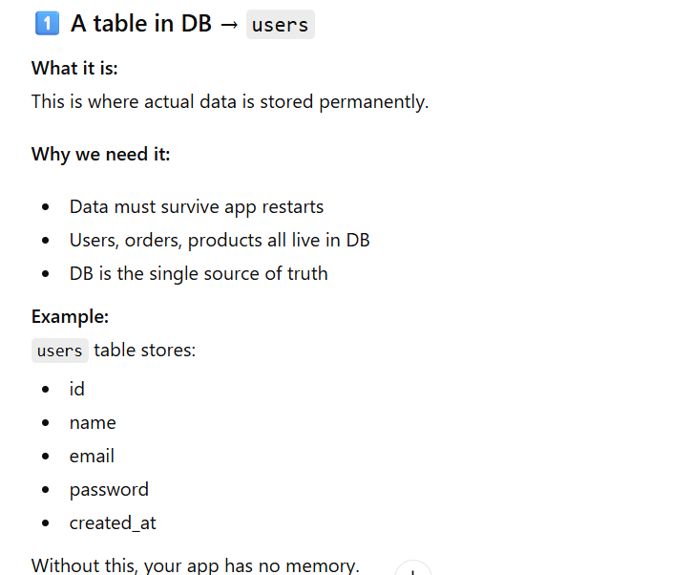
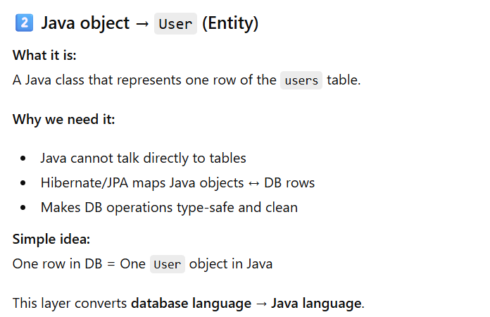

Explanation
- @Entity → tells Hibernate this is a DB table
- @Table(name="users") → explicit table name
- @Id → primary key
- @GeneratedValue → auto-increment
- @Email, @NotBlank → validation before DB hit
- unique=true → no duplicate emails
👉 This creates the users table automatically because:
spring.jpa.hibernate.ddl-auto=update

0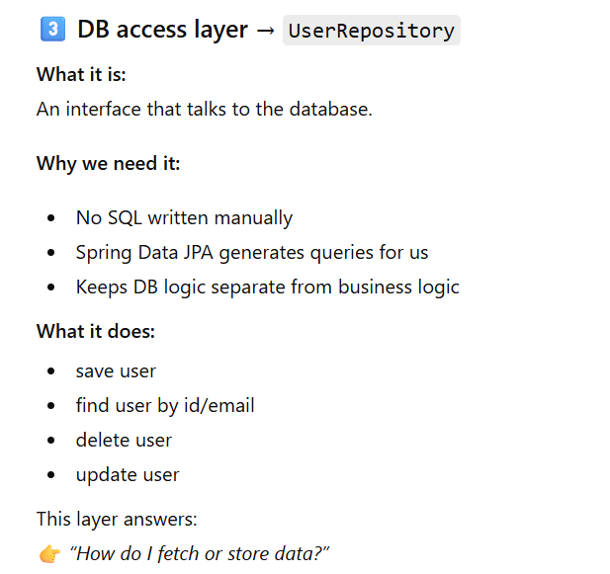

Explanation
- JpaRepository gives:
  - save()
  - findById()
  - findAll()
  - delete()
- findByEmail → Spring auto-generates query
- Optional → avoids NullPointerException

